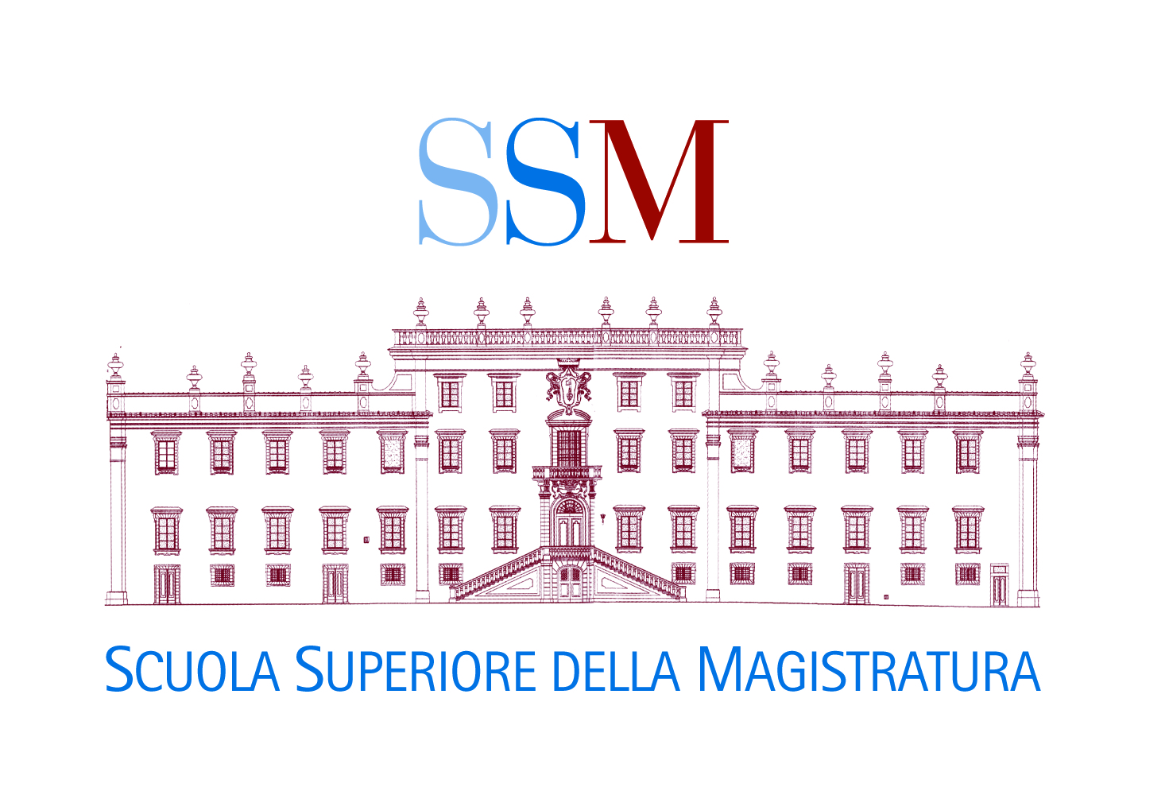

# 

# MEMORANDUM OF UNDERSTANDING MoU BETWEEN THE italian School FOR the Judiciary (*Scuola superiore della magistratura - SSM*) AND the European UNION Agency for Asylum (EUAA)

The **Italian School for the Judiciary (Scuola Superiore della Magistratura)** (hereinafter referred to as “*SSM*”)

And

The **European Union Agency for Asylum** (hereinafter referred to as “*EUAA*”),

Hereinafter jointly referred to as “*the Participants*”:

**Acknowledging** that the EUAA, as the centre of expertise on asylum, contributes to the coherent implementation of the EU’s Common European Asylum System (CEAS), that it facilitates, coordinates and strengthens practical cooperation among Member States on asylum issues and that it offers practical, technical and operational support including evidence-based input for EU policy making and legislation;

**Having regard** to Regulation (EU) 2021/2303 of the European Parliament and of the Council of 15 December 2021, establishing the European Union Agency for Asylum, in particular Articles 2(1)(d), 4,8, and 72 thereof;

**Recalling** the Decision of the Executive Director of the European Union Agency for Asylum (EUAA) on the rules for reimbursement of expenses incurred by participants invited to attend EASO activities;

**Having regard** to the Operational Plans that have been signed between the Italian Republic and the EASO/EUAA, in the framework of which, EASO/EUAA has been supporting since 2013 the capacity building process in the field of international protection, including at the level of courts and tribunals;

**Recalling** that Decree Law 13/2017, converted into Law 46/2017, establishing “*urgent provisions for the acceleration of proceedings on international protection*”, created specialised sections in the tribunals, responsible for immigration, international protection and free movement of EU citizens in 26 tribunals and entrusted the professional training of judges working in the specialised sections to the SSM, in collaboration with the EUAA and the United Nations High Commissioner for Refugees(UNHCR), on an annual basis, during the first three years of their assignment to the specialised sections;

**Recalling** that the EUAA manages a Courts and Tribunals Network, comprising representatives of courts and tribunals from across EU+ countries, European courts and judicial and other associations and that, in this context, the EUAA develops specific professional development material for members of courts and tribunals, facilitates horizontal judicial dialogue through its Network, organises judicial training workshops and other capacity building activities in the field of international protection;

**Whereas** the Council of the European Union’s Conclusions of 10 March 2021 underlines the critical role of judicial training in building a European judicial culture, based on the rule of law, mutual trust and respect for fundamental rights;

**Whereas** the Council invites FRA, EUROJUST, other Justice and Home Affairs agencies and their networks to: be fully involved in European judicial training; enter into working relationships with and provide support to the European and – where relevant and possible – national training providers for justice professionals;

**Acknowledging that** the SSM’s mandate is to ensure the implementation of the right and duty of members of the judiciary to follow professional training;

**Having regard** to Article 2 par. 4 of the *Statute of the* *SSM*, according to which, for the pursuit of its mandate and tasks, the SSM may avail itself of agreements, conventions or memoranda of understanding entered into with other public or private entities;

**Recalling** that, as per Article 2 par. 1 of its Statute, the SSM develops training standards and curricula, coordinates and delivers judicial initial and professional development training courses to members of the judiciary, takes part in cultural exchange programmes, study and research visits, as well as collaborates for the development of trainings with similar entities;

**Considering** that it is in the common interest of the Participants to contribute to judicial cooperation through learning and through strengthening training activities for judges and other officials performing judicial tasks, hence providing high-quality training in the field of international protection;

**Considering** that it is within the common interest of the Participants to establish a Memorandum of understanding MoU in the areas of mutual interest;

Have entered into the following Memorandum of understanding (MoU).

**Article 1**

**Purpose**

The purpose of this MoU is to develop a cooperation framework between the SSMand the EUAA, that will aim to ensure high-quality and effective support to the capacity building of Italian members of courts and tribunals in the field of international protection.

**Article 2**

**Scope of cooperation**

The Participants will cooperate, as follows:

1. The SSM will identify the training needs of Italian members of courts and tribunals in the field of international protection law and communicate them to the EUAA;
2. The Participants will jointly develop a structured programme of specialised professional development activities in the field of international protection for Italian members of courts and tribunals, on an annual basis, in accordance with SSM procedures; the structured programme of specialised professional development activities will be tailor-made to the training needs expressed by the Italian judges and, where appropriate, adapted to targeted categories of participants (trainee judges, senior judges, honorary judges, court staff members) and by level of specialisation of the activity (core or expert topics);
3. The SSM will circulate related calls for activities within the Italian judiciary and nominate participants with relevant profiles. Acting upon the recommendation of, and/or in coordination with the EUAA, the SSM will select the participants for these events;
4. The SSM, in cooperation with the EUAA, will also identify judicial experts and/or speakers for these activities. The judicial experts proposed by the EUAA will be members of the EUAA Judicial Experts Pool;
5. For all such activities, SSM will oversee the preparation of the training materials by having due regard to the EUAA Professional Development Series for members of courts and tribunals;
6. The SSM will disseminate the EUAA Professional Development Series and information on other EUAA activities, materials, calls for participants and calls for experts using the SSM’s procedures;
7. The Participants will keep each other duly informed on international protection law related activities;
8. The Participants will support each other in the development of international protection law related activities;
9. The SSM and the EUAA will coordinate on the implementation of other types of capacity building activities by the EUAA, aimed at providing technical assistance in specific areas, such as targeted support for enhancing case flow and backlog management.

**Article 3**

**Points of contact**

1. The Participants will establish points of contact whose task will be to coordinate the day-to-day cooperation on the implementation of and all communications relating to the present MoU.
2. The Participants will communicate to each other their respective points of contact through the channels indicated in par. 3.
3. The SSM and the EUAA will consult regularly via their respective points of contact, on policy issues and matters of common interest for the purpose of fulfilling their objectives and co-ordinating their respective activities.
4. Meetings between the SSM and the EUAA will take place as often as necessary to discuss issues relating to their cooperation in general and, in particular:

(a) the evaluation of their cooperation;

(b) the aspects of future cooperation;

1. The respective contact details of the SSM and the EUAA are the following:

|  |  |
| --- | --- |
| **Scuola Superiore della Magistratura** Via Tronto, 2  00198 ROMA Italy  Tel: +39 06 85 334 307 Fax: +39 06 85 271 270 E-mail: info@scuolamagistratura.it Website: [www.scuolamagistratura.it](http://www.scuolamagistratura.it) | **European Union Agency for Asylum**  MTC Block A  Winemakers Wharf  Grand Harbour Valletta  MRS 1917  Malta  Tel: +356 22487500  Email: [info@euaa.europa.eu](mailto:info@euaa.europa.eu)  Website: [www.euaa.europa.eu](http://www.euaa.europa.eu) |

**Article 4**

**Expenses and logistics arrangements**

1. The EUAA will cover expenses related to the organisation and conduct of professional development activities in accordance with EUAA rules governing the reimbursement of costs incurred by participants invited to attend EUAA activities. The expenses arising from the implementation of this MoU will be covered by the SSM according to its ordinary budget availability, without any additional cost for the State budget of the Italian Republic.
2. The EUAA will provide the premises and logistical support with regards to activities that take place in Malta. The SSM will provide the premises and logistical support with regards to activities that take place in Italy. Nevertheless, this support can also be provided by the EUAA when an activity is organised in a location other than those where the SSM has premises. When activities are carried out online, the EUAA will be responsible for managing the platform and the technical and logistical aspects of such activities.
3. Activities will take place either in Italian or in English with interpretation to Italian, where appropriate, to be provided by the EUAA.

**Article 5**

**Communication**

1. Communication of information and documents by the EUAA to the SSM will be subject to the EUAA's rules and regulations. Communication of information and documents by the SSM to the EUAA will be subject to the SSM’s rules and regulations.
2. The processing of personal data, exchanged between the Participants for the implementation of this MoU, will be governed by the respective rules and regulations.

**Article 6**

**Interpretation**

1. This MoU will be implemented in accordance with the Italian legislation, as well as applicable international and EU law.
2. This MoU does not constitute an international agreement which may lead to rights and obligations under international law. No provision of this MoU is to be understood and performed as a legal obligation or commitment of the Participants.
3. Any difference in the interpretation and/or application of the present MoU will be settled amicably through direct consultations and negotiations between the Participants.

**Article 7**

**Duration**

This MoU will remain valid until one of the Participants notifies the other of its intention to terminate it, three (3) months prior to the intended date of expiration.

**Article 8**

**Amendments**

The Participants may amend this MoU in writing by mutual consent.

**Article 9**

**Final dispositions**

This MoU takes effect on the date of signature.

Signed in Rome on 16 May 2022 in two originals in the English language, both texts being equally authentic.

|  |  |
| --- | --- |
| **For the Italian School for the Judiciary (Scuola Superiore della Magistratura - SSM)**  **Giorgio Lattanzi, President** | **For the European Union Agency for Asylum (EUAA)**  **Nina Gregori, Executive Director** |